13.2
AMS preprint volume, 13th Conference on Integrated Observing and Assimilation Systems for the Atmosphere, Oceans, and Land Surface, Phoenix, AZ 11-15 January 2009

Expanding collaboration in Joint OSSEs

M. Masutani^{1,#,10}, R. Errico^{2,$}, T. W. Schlatter⁵, J. S. Woollen^{1,+}, Y. Xie⁵, T. Zhu^{3,@}, N. Prive^{5,@},

R. Yang^{2,&}, L. P. Riishojgaard^{2,$,10}, A. Stoffelen⁷, G.-J. Marseille⁷, E. Andersson⁴,

F. Weng^{3,10}, T. J. Kleespies^{3,10}, O. Reale^{2,$}, G. D. Emmitt⁶, S. Greco⁶, S. A. Wood⁶,

C. Hill⁸, V. Anantharaj⁸, P. Fitzpatrick⁸, X. Fan⁸, H. Pryor², E. Salmon²,

H.- C. Liu²⁺, M. Sienkiewicz^{2,+}, A. da Silva²,H. Sun^{3,%}, Y. Song^{1*}, M. Govett⁵,

Z. Pu¹¹, L. Cucurull^{1,10}, S. J. Lord¹, D. Devenyi⁵, D. L. Birkenheuer⁵,

T. Jung⁴, A. Thompkins⁴, D. Groff^{1,+}, D. Kleist^{1,+}, R. Treadon¹, K. Fielding⁴, W. Lahoz¹⁷,

E. Brin², Z. Toth¹, Y. Sato^{1,9}, M. Hu⁵, S. Weygandt⁵, M. J. McGill²,

T. Miyosh⁹, T. Enomoto¹⁵, M. Watanabe¹³, H. Koyama¹³, Y. Rochen¹²

M. Seablom², B. I. Hauss¹⁴, R. Burn^{2,14}, G. Higgins¹⁴, R. Atlas¹⁸, S. Koch⁵,

H. Wang¹⁶, Y. Chen¹⁶, X.-Y. Huang¹⁶

¹NOAA/NWS/National Centeres for Environmental Prediction (NCEP), Camp Springs, MD
²NASA/Goddard Space Flight Center (GSFC), Greenbelt, MD
³NOAA/ National Environmental Satellite, Data, & Information Service(NESDIS), Camp Springs, MD
⁴European Centre for Medium-Range Weather Forecasts (ECMWF), Reading, UK
⁵NOAA/Earth System Research Laboratory(ESRL), Boulder, CO
⁶Simpson Weather Associates (SWA), Charlottesville, VA
⁷Royal Dutch Meteorological Institute (KNMI), DeBilt, Netherlands
⁸Mississippi State University/GRI (MSU), MS
⁹Japan Meteorological Agency (JMA), Tokyo, Japan
¹⁰Joint Center for Satellite Data Assimilation (JCSDA), MD
¹¹University of Utah, UT
¹²Environment of Canada, Ontario, Canada
¹³University of Tokyo, Japan
¹⁴Northrop Grumman Corporation
¹⁵Earth Simulator Center, JAMSTEC, Japan
¹⁶National Center for Atmospheric Research, Boulder CO
¹⁷Norsk Institutt for Luftforskning (NILU), Norway
¹⁸NOAA/OAR/The Atlantic Oceanographic and Meteorological Laboratory (AOML), Miami, FL
#Wyle Information Systems Inc., VA
⁺Science Applications International Corporation (SAIC), MD
$Goddard Earth Science and Technology Center, University of Maryland, Baltimore, MD
%QSS Group, Inc., MD
*I. M. Systems Group, Inc. (IMSG), MD
&Science Systems and Applications Inc (SSAI). MD
@Cooperative Institute for Research in the Atmosphere (CIRA)/CSU, CO

1. Full OSSE

Building and maintaining observing systems (OS) with new instruments is extremely costly, particularly when satellites are involved. Objective methods that can evaluate the improvement in forecast skill due to the selection of instruments and configurations have long been sought. The forecast skill evaluation using simulation experiments with a proxy truth atmosphere called

Corresponding author address:. Michiko Masutani, Wyle information systems at NOAA/NWS/NCEP/EMC, 5200 Auth Road Rm 207, Camp Springs, MD 20746 Michiko.masutani@noaa.gov
Nature Run is known as an Observing System Simulation Experiments (OSSEs, Arnold and Dey 1986, Lord et al 1997) have been proposed. Although the OSSE itself is a very expensive project, the cost of an OSSE is a small fraction of the total cost of an actual OS.

Various simplified observing system simulation experiments have been attempted and are often called OSSEs (Masutani et al 2009). In a Joint OSSE, the term OSSE refers to a simulation experiment with a Nature Run model significantly different from the Numerical Weather Prediction (NWP) model used for data assimilation. These are assessed based on calibration experiments, where real and simulated data impacts are compared. We call this OSSE as "full OSSE" to distinguish other simulation experiments.

By running full OSSEs, current operational data assimilation systems (DAS) will be evaluated, improved and upgraded to handle new data types and their volume, thus accelerating the use of future instruments and OS design. Additionally, OSSEs can hasten database development, the development of data processing techniques and quality control softwares. All of these will accelerate the operational use of new OSs. Through the OSSEs future OS will be designed that can be effectively used by DAS and forecast systems to improve weather forecasts, thus giving the maximum societal and economic benefits.

2. Collaboration and coordination in OSSEs

OSSEs also require the best knowledge in many areas of the Numerical Weather Prediction (NWP) system. The Nature Run has to be produced using a state of art NWP model at the highest resolution. Simulating data from a Nature Run requires experts for each instrument. Simulations and assimilations have to be repeated with various configurations. Efficient collaborations are essential for producing timely and reliable results.

From the experience of the OSSEs performed during recent decades, we realize that introducing a new Nature Run consumes significant amount of resources. The simulation of observations requires access to the complete model level data and a large amount of resources, and it is important that the simulated data from many institutes be shared among all the OSSEs. By sharing the Nature Run and simulated data, OSSEs will be able to produce results which can be compared, which will enhance the credibility of the results. Based on these experiences a broad group of US and international partners formed the "Joint OSSEs" (Masutani et al. 2007, Masutani et al. 2008).

3. Nature Run

3.1 Requirement for the Nature Run

The Nature Run is a long, uninterrupted forecast by a model whose statistical behavior matches that of the real atmosphere. The ideal Nature Run would be a coupled atmosphere-ocean-cryosphere model with a fully interactive lower boundary. Meteorological science is approaching this ideal but has not yet reached it. For example, it is still customary to supply the lower boundary conditions (SST and ice cover)
appropriate for the span of time being simulated.

In Joint OSSEs, succession of analyses are not being used for the Nature Run. In the case of four-dimensional variational assimilation (4D-VAR), although the analyses may each be a realizable model state, they all lie on different model trajectories. Each analysis marks a discontinuity in the model trajectory, determined by the information content extracted by a DAS from the existing global observing systems and forced by observations. Furthermore, residual systematic effects due to the spatially non-uniform and often biased observations, the DAS, or the model state, may either favorably or unfavorably affect the potential of new observing systems to improve the forecasts. Thus, considering a succession of analyses as truth seriously compromises the attempt to conduct a “clean” experiment.

The advantage of a long, free-running forecast is that the simulated atmospheric system evolves continuously in a dynamically consistent way. One can extract atmospheric states at any time. Because the real atmosphere is a chaotic system governed mainly by conditions at its lower boundary, it does not matter that the Nature Run diverges from the real atmosphere a few weeks after the simulation begins provided that the climatological statistics of the simulation match those of the real atmosphere. A Nature Run should be a separate universe, ultimately independent from but representative of the real atmosphere.

3.2 Joint OSSE Nature Run

The Nature Runs and simulated data ought to be shared between many institutes carrying out the actual OSSEs. OSSEs with different Nature Runs are difficult to compare but OSSEs using different DAS and the same Nature Run can provide a valuable crosscheck of data impact results.
The primary specifications for a new Nature Run are:

• To cover a long enough period to span all seasons and to allow selection of interesting sub-periods for closer study;
• To provide data at a temporal resolution higher than the OSSE analysis cycle;
• Simulates the atmosphere at scales compatible with the main OS;
• To use daily SSTs;
• To have user-friendly archiving.

Based on the recommendations from NOAA and NASA, ECMWF produced a new Nature Run in July 2006 at T511 (40 km) spectral truncation and 91 vertical levels, with the output saved every 3 hours. Two high resolution Nature Runs at T799 (25km) horizontal resolution and 91 vertical levels have been generated to study data impacts when forecasting hurricanes and midlatitude storms. The output is saved every hour. A hurricane period from September 27 to November 1 was selected. A period from April 10 to May 15 was selected to study midlatitude storms. The version of the model used was the same as the interim reanalysis at ECMWF (cy30r1). The initial condition is the operational analysis on 12Z May 1st, 2005 and the Nature Run ends at 00Z June 1st, 2006. The model was forced by daily SST and ice provided by NCEP (also used in the operational forecasts) which is used throughout the experiments.

The complete data for the T511NR and T799NR are saved at ECMWF, NCEP, NASA/GSFC, and ESRL. The complete Nature Runs are accessible from the NASA/GSFC/NCCS portal system. Access to the data from this site requires an account, which is available to the research community. The complete Nature Runs will also be available from ECMWF. Verification data (1degx1deg data)for the T511NR are also available from NCAR/ CISL Research Data Archive as data set ID ds621.0 and JMA. Complete verification data for T511NR and T799 NR are also available from NRL/Monterey, University of Utah, and Mississippi State University. (Masutani et al 2008)

3.3 Evaluation of the Nature Run

Midlatitude cyclone statistics were produced using Goddard’s objective cyclone tracker. Distribution of cyclone strength across the pressure spectrum, cyclone lifespan, cyclone deepening, regions of cyclogenesis and cyclolysis, distribution of cyclone speed and direction are studied. All statistics showed the Nature Run is within interannual variability (Masutani et al 2007). Location and intensity of the jet was found to be realistic. The cloud cover were also evaluated and found to be much improved from any other nature runs (Fig.1).
Once over the Atlantic Ocean, signs of the development and organization of some waves into smaller-scale circulations are observed. In particular, the ECMWF Nature Run seems to also show the capability of spontaneously producing realistic Atlantic hurricanes.These findings, albeit preliminary, are suggestive that the ECMWF Nature Run simulates a realistic meteorology over tropical Africa and the nearby Atlantic and may prove itself beneficial to OSSE research focused over the AMMA or the Atlantic Hurricane regions (Reale et al 2007).

4. Progress in simulation of observations and calibration

Simulation of observations requires experts from every instrument. Since this process requires access to the full resolution of the Nature run, computing facilities with large memory are required. If the observational errors, added to the true values extracted from the nature run, are properly specified, then the statistical behavior of the assimilation system will be similar in the simulated and real worlds, and the OSSE will be properly calibrated. The calibration process is time consuming and calibration was not often performed in most of OSSEs except for the OSSE at NCEP (Masutani et al. 2006).

Initial preliminary simulation of conventional data was conducted by NCEP, NESDIS and ESRL. The data are made available to Joint OSSE for calibration purpose. In order to simulate radiance data, vertical profiles were generated at the based on actual operational usage to keep some statistics similar to a real assimilation. Initial simulation of GOES, AMSUA and AMSUB radiance data are also completed for the whole period of the T511 NR.

An extensive effort for simulation of observations was conducted at NASA/GSFC/Global Modeling and Assimilation Office (GMAO.) GMAO simulator has been set up to simulate HIRS2, HIRS3, AIRS, AMSUA, AMSUB, MSU radiance data as well as conventional data. Calibration experiments were also conducted at GMAO using an adjoint technique (reference, e.g. Gelaro et al.)

GMAO simulation software includes:

• Software for generating conventional obs (Observation type included in NCEP .prepbufr file)
The codes are set up for raobs, aircraft, ships, vad winds, wind profilers, surface station data, SSMI and Quick scat surface winds, Cloud Motion Vector (CMV)
• Software for simulating radiances
Code to simulate HIRS2/3, AMSUA/B, AIRS, MSU has been set up. Community Radiative Transfer Model (CRTM) is used for forward model.
• Software for generating random obs. error
Observations are generated without errors but software to simulate error is provided.

The output of the data is saved in BUFR format which can be read by the Gridpoint Statistical Interpolation (GSI). GSI is a DAS used at NCEP, GMAO and ESRL. The codes are flexible and include many tunable parameters. The codes will be available to Joint OSSE and software is well documented. Since the software will continued to be developed, all interested people are expected to contact GMAO (Ronald Errico: ronald.m.errico@nasa.gov) or Joint OSSE (Michiko Masutani: michiko.masutani@noaa.gov). The GMAO simulation software was successfully installed at NCEP and initial simulation AIRS, HIRS2 and HIRS3 radiance data were completed for the entire period of T511 NR. It is also versatile to simulate other observing systems.

Calibration using the adjoint technique has been conducted at GMAO and remarkable similarity between simulated data impact and real impact has been achieved. Further detail adjustments are being conducted. ESRL, NCEP, and NESDIS are working on calibration experiments including GOES. Some initial results are reported by Privé et al (2009). Significant inconsistent results are observed in data impact of CMV and SSMI winds, that is possible due to the preliminary sampling strategies. In initial simulation, CMVs have been simulated using actual observation locations. SWA has developed strategies for realistic sampling of CMV from the Nature Run and a coordinated effort will be conducted to simulate more realistic CMV.

Alternative software to simulate radiance data using the Stand-alone AIRS Radiative Transfer Algorithm (SARTA) as well as the CRTM is also being developed at NESDIS. NESDIS software includes results from various research. This will be important to evaluate CRTM in Joint OSSEs.
The preliminary data used for ongoing calibration require further tuning and evaluations and should be used with caution. These are useful to build and test scripts and are made available to participating scientists who are expected to share the results.

5. Expanding collaboration

The joint effect to conduct global OSSEs is a productive sharing of the strengths and resources of the participants. Many groups have expressed interest in conducting OSSEs within Joint OSSE and seeking funding to conduct OSSEs.
Various experiments to evaluate future and current instruments are proposed:

• Various DWL designs and configurations proposed by both NASA and the European Satellite Agency (ESA)
• Additional Radio Occultation observations
• UnManned Aircraft System (UAS, Prive et al. 2009)
• Investigate the usage of GOES radiance data in real assimilation and preparation for GOES-R data.
• Evaluation of GOES-R and NPOESS instruments

OSSE will be also used to design and evaluate observing systems
• Evaluation of targeted observing system
(UAS, DWL and T-PARK related project)
• Targeted sampling of satellite data.
• Interacting effect among various observing systems.

Some groups are interested in using OSSEs to study DAS
• Data impact in climate data assimilation
• Study of error in DAS
• Comparison of various data assimilations system

There is great deal of interest toward regional OSSEs to study data impact on forecast of hurricanes and midlatitude storms. Even if using same global Nature run, regional OSSEs have to deal with handicaps.

• Lateral boundary conditions eventually dominate the forecast inside the regional domain, obscuring any effect of the observation mix on forecast accuracy. This must be considered when evaluating the OSSE:
• The size of the geographic region controls the length of forecasts that can be considered shorter for smaller regions.
• Ideally, the same observation mix should be used in the regional model as in the global model that supplies the boundary conditions.
• One is forced to execute two nature runs and coordinate two data assimilation and prediction systems.

If regional Nature Runs with higher resolution is produced nesting within the global nature run, uncertainty in regional OSSE will become much more serious. Several groups in Joint OSSEs are investigating strategies for credible regional OSSEs.

6. Summary and concluding remarks for OSSEs

The OSSEs (Masutani et al. 2006, Woollen et al. 2007) have demonstrated that carefully conducted OSSEs are able to provide useful recommendations which influence the design of future observing systems. Based on this work, OSSEs can be used to investigate:

- The effective design of orbit and configuration of an observing system;
- The effective horizontal and vertical data density;
- The evolution of data impact with forecasts;
- The balance between model improvement and improvements in data density and quality;
- The combined impacts of mass (temperature) data and wind data;
- The development of bias correction strategies.
- OSSEs should also be used to design
optimal sampling strategies (example: aircraft flight patterns and sensor payloads).

Ideally, all new instruments should be tested by OSSEs before they are selected for construction and deployment. OSSEs will also be important in influencing the design of the instruments and the configuration of the global observing system. While the instruments are being built, OSSEs will help prepare the DAS for the new instruments. Developing a DAS to assimilate a new type of data is a significant task. However, this effort has traditionally been made only after the data became available. The OSSE effort demands that this same work be completed earlier; this will speed up the actual use of the new data and proper testing, increasing the exploitation lifetime of an innovative satellite mission.

OSSEs will be conducted by various scientists with different interests. Some want to promote particular instruments while others may want to aid in the design of the global observing system. Specific interests may introduce bias into OSSEs but they also introduce strong motivations. Operational centers such as NCEP will perform the role of finding a balance among conflicting interests to seek an actual improvement in weather predictions. They may be unbiased but often have a difficult time finding resources.

Acknowledgments

Throughout this project many staffs at NOAA/NWS/NCEP, NASA/GSFC/GMAO, NOAA/NESDIS/STAR, NOAA/ESRL/GSD, JCSDA and ECMWF contributed.

References

Arnold, C. P., Jr. and C. H. Dey, 1986: Observing-systems simulation experiments: Past, present, and future. Bull. Amer., Meteor. Soc., 67, 687-695.
Errico, R.M., R. Yang, M. Masutani, M., and J. Woollen, 2007: Estimation of some characteristics of analysis error inferred from an observation system simulation experiment. Meteor. Zeitschrift, 16, 695-708.
Lord, S. J., E. Kalnay, R. Daley, G. D. Emmitt, and R. Atlas 1997: Using OSSEs i.n the design of the future generation of integrated observing systems. AMS Preprint volume, 1st Symposium on Integrated Observation Systems, Long Beach, CA, 2-7 February 1997.
Masutani, M., J. S. Woollen, S. J. Lord, T. J. Kleespies, G. D. Emmitt, H. Sun, S. A. Wood, S. Greco, J. Terry, K Campana, 2006: Observing System Simulation Experiments at NCEP. NCEP Office Note No.451.
Masutani, M., E. Andersson, J. Terry, O. Reale, J. C. Jusem, L.-P. Riishojgaard, T. Schlatter, A. Stoffelen, J. S. Woollen, S. Lord, Z. Toth, Y. Song, D. Kleist, Y. Xie, N. Priv, E. Liu, H. Sun, D. Emmitt, S. Greco, S. A. Wood, G.-J. Marseille, R. Errico, R. Yang, G. McConaughy, D. Devenyi, S. Weygandt, A. Tompkins, T. Jung, V. Anantharaj, C. Hill, P.Fitzpatrick, F. Weng, T. Zhu, S. Boukabara 2007: Progress in Joint OSSEs, AMS preprint volume for 18th conference on Numerical Weather Prediction, Parkcity UT. 25-29 June, 2007.
Masutani, M., J. S. Woollen, R. Errico, Y. Xie, T. Zhu, H. Sun, J. Terry, R. Yang,S. Greco, N. Prive, E. Andersson, T. W. Schlatter, A. Stoffelen, F. Weng, O. Reale,L. Riishojgaard, G. D. Emmitt, S. Lord, Z. Toth, G.J. Marseille, V. Anantharaj, K. Fielding, G. McConaughy, S.Worley, C.-F. Shih, M. Yamaguchi,J. C. Jusem, C. Hill, P. J. Fitzpatrick, D. Devenyi, S. Weygandt, S. A. Wood, Y. Song,E. Liu,D. Groff, M. Hart, G.Gayno, A. da Silva, M. J. McGill,D. Kleist Y. Sato, S. Boukabara, 2008: Progress in Joint OSSEs. Three Joint OSSE nature runs and simulation of observation, AMS preprint volume, 12th Conference on Integrated Observing and Assimilation Systems for the Atmosphere, Oceans, and Land Surface, New Orleans, LA, 20-24 January 2008
Masutani, M. and others, 2009: International Collaborative Joint OSSEs. Toward reliable and timely assessment of future observing systems. AMS preprint volume, Anthony Hollingsworth Symposium, Phoenix, AZ 11-15 January 2009.
Privé N., Y. Xie, T.W. Schlatter, M. Masutani, R. M. Atlas, Y. Song, J. Woollen, and S. Koch 2009: Observing System Simulation Experiments for Unmanned Aircraft Systems- preliminary efforts. AMS preprint volume, 13th Conference on Integrated Observing and Assimilation Systems for the Atmosphere, Oceans, and Land Surface, Phoenix, AZ 11-15 January 2009
Reale O., J. Terry, M. Masutani, E. Andersson, L. P. Riishojgaard, J. C. Jusem (2007), Preliminary evaluation of the European Centre for Medium-Range Weather Forecasts' (ECMWF) Nature Run over the tropical Atlantic and African monsoon region, Geophys. Res. Lett., 34, L22810, doi:10.1029/2007GL031640.

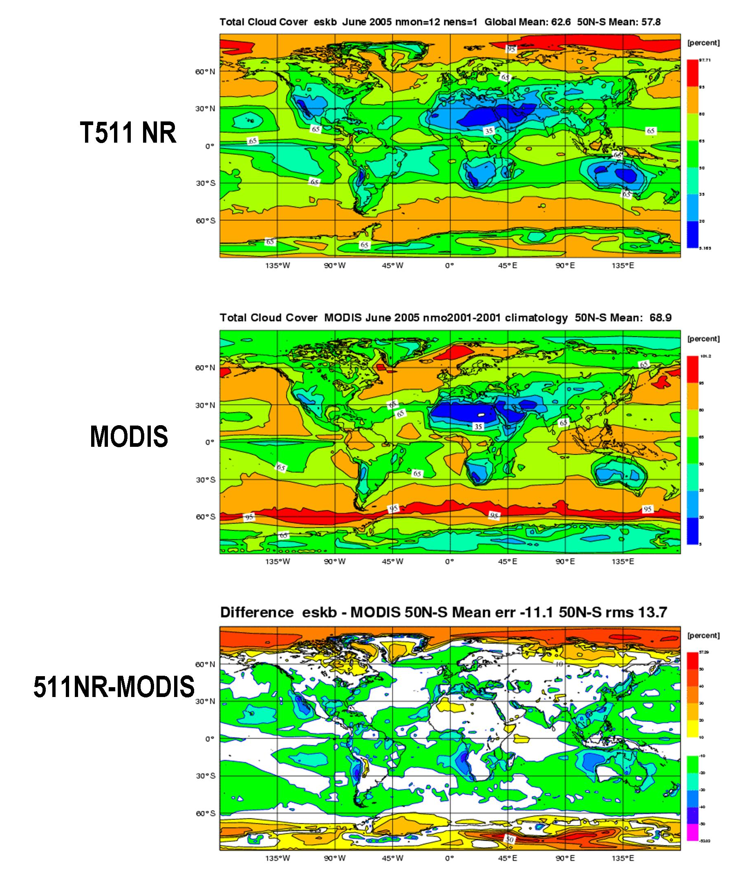
Fig. 1 Annual mean total cloud cover. T511NR and observed estimate from MODIS data.

