NHC Forecast Verification Software Documentation
Version 4.11

James Franklin
13 September 2021

- Introduction
This document describes verify_model, an application that performs NHC verification functions on the Atlantic, eastern Pacific, and central Pacific forecast aids contained in Automated Tropical Cyclone Forecast System (ATCF) databases. The Fortran application runs in the Linux and Mac environments. The sections below cover installation and setup, program usage, output files, special notes about program operation and limitations, recommendations on best practices, and a recent revision history.
In what follows, Courier fixed-width font is used to help distinguish regular text from program names, files, directories, input responses, or program outputs.

- Installation and Setup
The application code is verify_model.f, and associated subroutines are contained in atcflib.f and sondelib.f. All Fortran modules can be compiled with gfortran. The sondelib.f module will generate some compilation warnings about legacy functions that are not considered to be modern Fortran.
A base directory should be created to house the verify_model code, executable, and associated scripts and files. Beneath this base directory the following subdirectories are required:
data Contains the ATCF a-decks and b-decks used as input to verify_model. Historical decks will need to be copied from the ATCF archives and unzipped, while decks from the current season should be copied from the ATCF storms directory.
model_logs Subdirectory for output from verify_model.
support_files Contains various datasets required by the application:
aland_pac.dat
aland.dat
clim_rsst.dat
clp5_al3104coeff.dat
clp5_al6100coeff.dat
clp5_ep4904coeff.dat
clp5_ep6100coeff.dat
clp5_gm3103coeff.dat
clp5_gm6100coeff.dat
oban_WH.dat
wland.dat

The following associated files should be in the base directory:

verify_model.gfcl Compiles the application
verify_model Executable file
verify_model.cmd Main script to run the application
verify_model_options.txt User-editable file of program options
verify_model_intplist.txt User-editable file of 12-h interpolated models
verify_model_fcstlist.txt Input file for verifying from a list of storms/times
verify_model_cona.txt User-defined variable consensus
verify_model_conb.txt User-defined variable consensus
verify_model_conc.txt User-defined variable consensus
verify_model_cond.txt User-defined variable consensus
verify_model_cone.txt User-defined variable consensus
verify_model_conf.txt User-defined variable consensus
verify_model_cong.txt User-defined variable consensus
verify_model_conh.txt User-defined variable consensus
verify_model_coni.txt User-defined variable consensus
verify_model_conj.txt User-defined variable consensus
verify_model_conx.txt User-defined fixed consensus
verify_model_cony.txt User-defined fixed consensus
verify_modelrx.cmd Script to enable multiple runs
verify_model_allyears.cmd Sample script to make multiple runs
wwpts_all.txt Database of all coastal TC watches/warnings
wwpts_us.txt Database of U.S. coastal TC watches/warnings
LIBPATH.keep Contains the path to the library modules

The base directory needs to be specified in verify_model.cmd, verify_modelrx.cmd, and verify_model_allyears.cmd. The library modules atcflib and sondelib usually reside in a separate library directory, which is specified in LIBPATH.keep.

- Usage and Options

  - Check option settings
Before starting a verification, check the verify_model_options.txt file to make sure that the program options are set as desired. The recommended/normal settings for each option are given at the end of each line in the file. These options are discussed individually in section 3.c below.

  - Run verify_model.cmd
Depending on the installation, this script may precede the queries below with a question about pulling fresh data from the ATCF. After that, the following basic questions are asked regarding how the verification sample should be defined. Brackets denote default responses that you can invoke by just hitting return. In all the questions that follow, responses may be given in either upper or lower case.

- Enter ATCF storm ID to process:
The response follows the ATCF format of BB##YYYY, where BB is the basin, ## is the cyclone/storm number, and YYYY is the year. For example, to verify the fifth Atlantic cyclone of 2017, you’d enter AL052017.
You can also run a verification for all the storms of a single year. To do this, for the cyclone number ## enter SY (for “single year”). For example, to verify all the eastern Pacific cyclones of 2012 you’d enter EPSY2012.
To verify all storms over a range of years, you would enter the basin, then MY for the cyclone number (for “multiple years”), followed by the two-digit starting and ending years of the period of interest, century omitted. For example, to request a verification of all Atlantic cyclones from 1998 to 2003 you’d enter ALMY9803.
The program supports the following options for basin: AL, EP, CP, AE, and EC, the latter two representing combined Atlantic/eastern Pacific and combined eastern and central Pacific basins, respectively.

- Number of models to verify [1]:
Specify the number of models (up to 20) to be verified as a homogeneous sample (in a homogeneous sample all the requested models must be present at a particular verifying time for that verifying time to be included in the sample).

- Enter model to verify [ofcl]:
Enter the models comprising your desired homogeneous sample by specifying their standard ATCF identifiers, one at a time. You’ll get as many prompts as the number you specified in response to the previous question. The default choices for the first and second models are OFCL and OCD5, respectively.
- Enter min, max WS to verify [0,200]:
Here you can restrict the sample by any desired range of system intensity. By default, this wind speed test is applied at both the initial time and the verifying time (although see the relevant option in section 3.c below). For example, if you want to exclude depressions from the verification, enter 34,200.

- Verify subtropical stages [y]?
Answer n if you want to exclude subtropical cyclone stages. The cyclone status is tested at both the initial time and the verifying time.

- Verify extratropical stages [n]?
Answer y if you want to include extratropical stages. The cyclone status is tested at both the initial time and the verifying time.

- Verify post-dissipation stages [n]?
Responding y will invoke a special option that penalizes poor forecasts of cyclone dissipation that would normally be ignored. Under standard verification rules, a system needs to be a TC at both the initial and verifying times, so if a forecast intensity is 100 kt but the system dissipated instead, there’s no penalty for that lousy intensity forecast - or similarly, if the forecast was for dissipation and the actual TC verifying intensity was 100 kt. Invoking the post-dissipation option assigns a fixed intensity (usually 15 kt) to either the forecast or verifying intensity if none exists in the a-deck or b-deck, and thus provides a more realistic (albeit non-standard) assessment of intensity errors. The assigned intensity value for this purpose can be changed in verify_model_options.dat.

- Select Watch/Warning option [n]:
This allows you to restrict the sample based on whether coastal tropical cyclone watches or warnings were in effect at the time the forecast was either issued or was being verified, according to the options listed below. The watch/warning history file name is specified in verify_model_options.dat, and the selection options are:
n Include all forecasts without regard to watch/warning status.
h Include only forecasts issued when hurricane W/W were in effect.
i Include only forecasts issued when any W/W were in effect.
j Include only forecasts issued when no W/W were in effect.
v Include only forecasts that verify when W/W were in effect.
w Include only forecasts that verify when no W/W were in effect.

- Verify forecasts from list [n]?
If, having already defined the verification sample through the responses thus far, you’d like to further restrict the sample to just a specific subset of storms and times, you can do that here. The list of desired storm IDs and date/time groups must have been previously entered, one per line, in verify_model_fcstlist.txt. The first line of this file should be a comment (up to 60 characters) describing what the list represents (e.g., “Forecasts within 3 h of an aircraft fix.”). Each subsequent line should contain an 8-character ATCF storm ID, a space, then the desired six-character date/time group (mmddhh).
Allowable responses to the query are:
n Include all forecasts without regard to what’s in the list.
i Include only forecasts issued at times in the list (“y” also gives you this).
b Include only forecasts issued and verifying at times in the list.
e Exclude all forecasts issued at times in the list.

- Verify forecaster [all]:
If you want to restrict the sample to just the OFCL forecasts issued by a particular person, enter his or her 3-character ATCF identifier here. This query only appears if OFCL is one of the models requested. The default response all gives you everyone’s forecasts.

After all these questions have been answered, verify_model will perform the verification. As the program runs, it will write to the terminal each time it opens a new storm’s files and the current date/time group it’s working on.

  - Options available in verify_model.options.dat
Some of the less-frequently-changed options are managed by the contents of this file, an example of which is shown below. Some of these options were implemented to satisfy a particular investigation at some point in the distant past and are no longer commonly used, while others have been proven to be useful on a more regular basis.

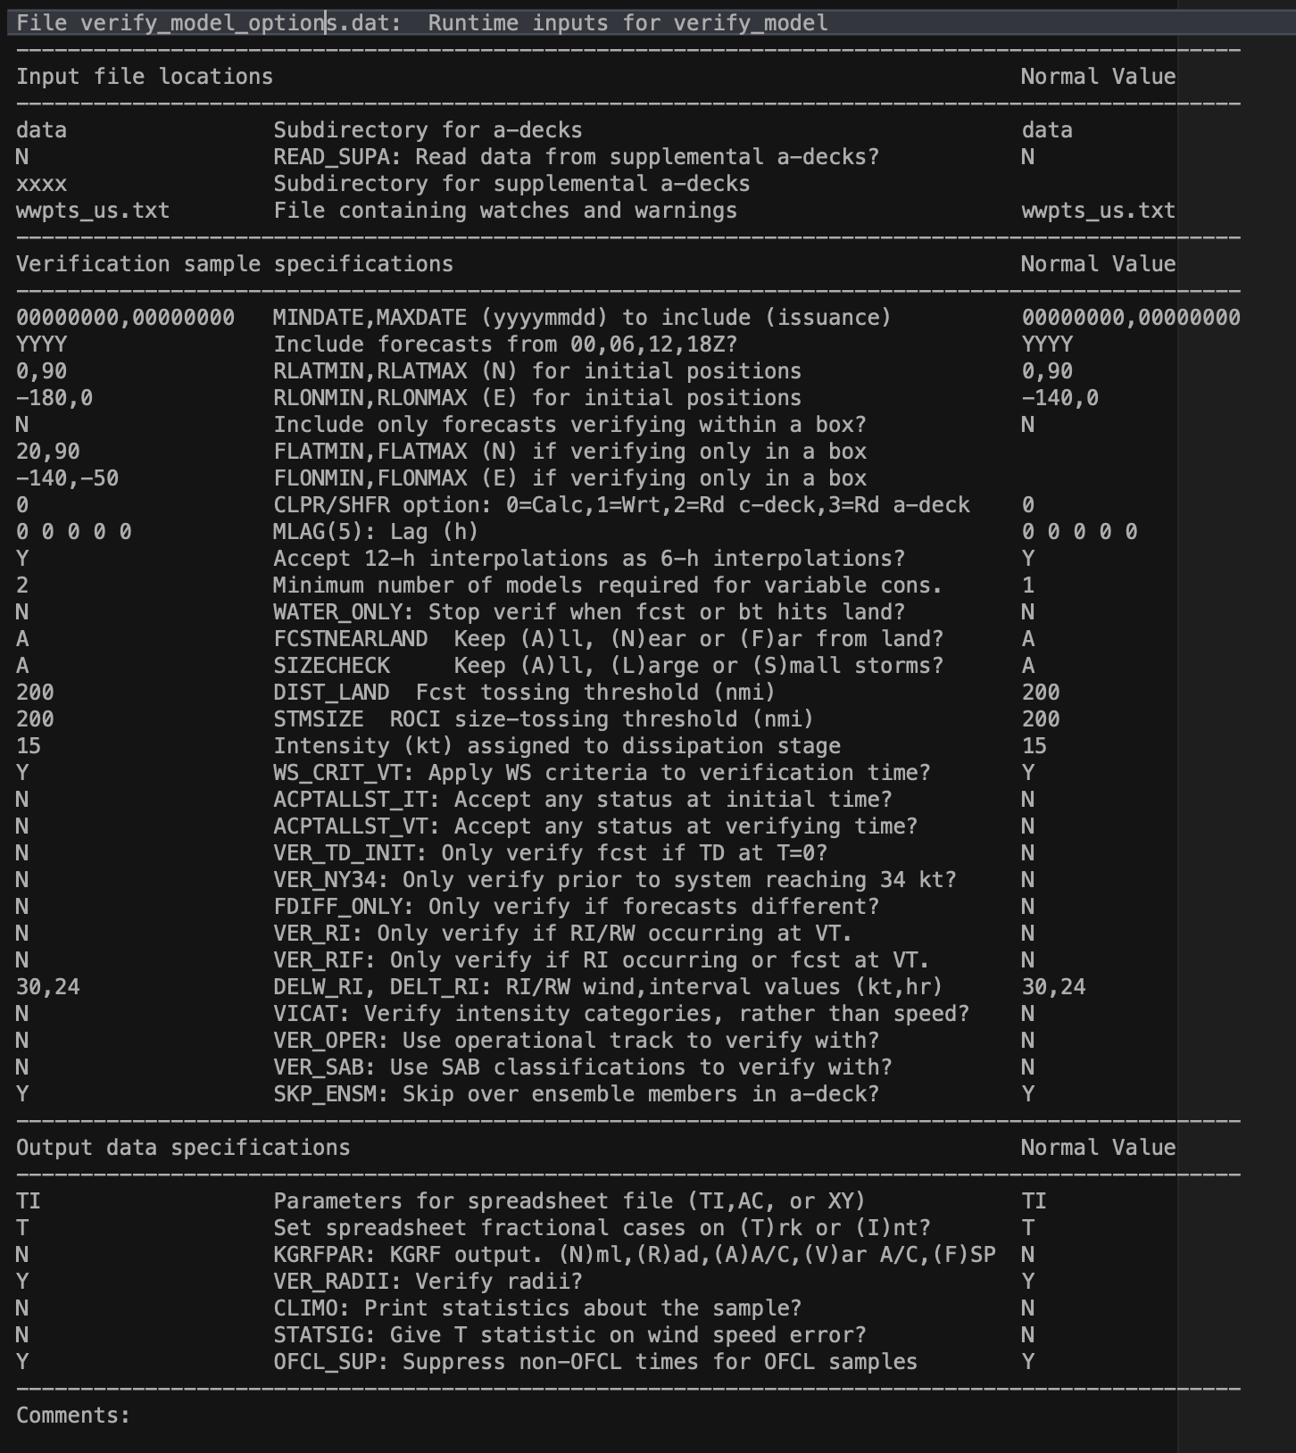

Things that you can change by editing verify_model_options.dat prior to running the application are:
- Subdirectory where the primary ATCF decks reside. Only a four-character name is allowed. Normal setting is data.
- Option to read from a supplementary set of a-decks. Use this if you are verifying models that are not present in the official NHC a-decks but have been provided from another source. When invoked, the contents of the primary decks and supplementary decks are combined in program memory so that you can run a homogeneous sample with the regular NHC models. Normal setting is N.
- Name of the subdirectory where the supplementary a-decks are located. Only a four-character name is allowed.
- Name of the file containing watch/warning history. Choose whether you want the file containing all W/W or just the U.S. W/W.
- Restrict the verification to a particular time period. Set the beginning and end of the desired period in yyyymmddhh format. All the normal sample restrictions defined when running verify_model.cmd still apply. This option can be useful if an operational model is updated mid-season and you want to only look at a particular version of the model. Normal setting is 00000000,00000000 to accept all times.
- Include or exclude forecasts initiated from each of the four standard synoptic times. Normal setting is YYYY.
- Restrict the verification sample to those forecasts initiated within a particular lat/lon domain. Normally these should be set to the NHC AOR (mainly so that CPHC’s OFCL forecasts for EP storms don’t get included in NHC verifications).
- Restrict the verification sample to those forecasts that verify in a particular lat/lon box.
- Determine where the skill baseline forecasts (e.g., OCD5, BCD5, TCLP) are taken from. You can choose to calculate these on the fly, read them from the regular a-decks, or read them from a special set of supplementary decks in the main data directory (the “c-decks”). Normal setting is 0. Choosing option “1” here will both calculate them on the fly and create the c-decks for future use. While it is faster to read them from the a-decks or c-decks, sometimes these skill benchmarks are missing from the official decks and you get a more complete sample by calculating them on the fly. Another advantage of calculating them at runtime (for BCD5) is that you’re guaranteed to get a forecast consistent with the current state of the best track (since old best tracks sometimes change).
- Lag a forecast. Sometimes it is of interest to compare the current forecast of one model with a less-current forecast of another model. For example, one might want to know if the 6-h-old ECMX is better than the current AVNO. To answer this question, you’d run a homogeneous comparison of AVNO and ECMX, and set the lag for ECMX equal to 6. The program would then compare each AVNO with the ECMX from 6-h prior, verifying the 18-h ECMX forecast against the 12-h AVNO forecast, the 30-h ECMX against the 24-h AVNO, etc. Any of the first five models being verified can be lagged by up to 24 h in 6-h intervals. When invoking this option, take care to choose models that actually have forecasts at the lagged times of interest. Normal setting is 0 0 0 0 0.
- Substitute 12-h (“2”) interpolated models if the 6-h (“I”) interpolation isn’t available. This is appropriate for dynamical models that are only run at 00 and 12Z, such as the ECMWF and UKMET. For such models there would not be a 00 or 12Z ECMI or UKMI, but there would be an ECM2 and UKM2. Normal setting is Y. The list of models for which this substitution is applied is in file verify_model_intplist.dat.
- Set the minimum number of models needed when computing a variable consensus. Normal setting is 1.
- Restrict the verification sample to the portion of the forecast or best track prior to landfall. When this option is invoked, both the best track and each of the requested model tracks are examined for the first landfall. No verifications for that set of forecasts are included after any of the models or the best track encounters land. Note, however, that the tracks associated with any of the skill baselines (e.g., OCD5, BCD5, etc.) are not checked for landfalls. Normal setting is N.
- Restrict the verification sample on the basis of the distance of the verifying point to land. Normal setting is A.
- Restrict the verification sample on the basis of initial storm size (radius of outermost closed isobar). Normal setting is A.
- Threshold value (n mi) for the distance-to-land option.
- Threshold value (n mi) for the storm-size option.
- Set the intensity (kt) substituted for forecasts or best track when dissipation stage forecasts are included, and the actual intensity is missing from the best track or the forecast. Normal value is 15.
- Specify whether the wind speed criteria (set in verify_model.cmd) should also apply to the verification time (the normal setting, Y) or whether it should apply only to the initial time.
- Specify whether to accept normally unacceptable system status flags at the initial time (e.g., disturbance, wave, low, extratropical). This option would be invoked if one were interested in verifying forecasts for potential tropical cyclones, which would be issued for systems that were not yet tropical or subtropical cyclones. Normal setting is N.
- Specify whether to accept normally unacceptable system status flags at the verifying time. Normal setting is N.
- Specify whether to only accept systems that were a depression at the initial time. This capability was added for a very specific line of inquiry and might never be used again. Normal setting is N.
- Specify whether to terminate a forecast verification once the best track reached 34 kt or higher. Similarly useless, in all probability. Normal setting is N.
- Restrict the sample to only those verification times when there were differences among the various models being evaluated (i.e., this option tosses all track verification times where all the models had the same forecast position, and tosses all intensity verification times where all the models had the same forecast intensity. This can be useful, for example, if you’re comparing two very similar models and only are interested in those cases where the models are different.
- Restrict the verification sample to only those times when rapid intensification or weakening was occurring in the best track for the specified period (see below) ending at the verification time. Normal setting is N.
- Restrict the verification sample to only those times when rapid intensification was occurring either in the best track or was forecast, for the specified period (see below) ending at the verification time. Normal setting is N. Note that a forecast of RI in any of the forecasts composing the sample, including members of a user-specified consensus, will trigger the inclusion of that case in the verification sample.
- Specify the desired definition of RI/RW, in terms of intensity change (kt) in a designated time interval (h). Please ensure that the time interval provided is an even multiple of the best track resolution (6 h). Normal setting is 30,24. Specify an RW sample with a negative intensity change (e.g., -25,24).
- Perform a categorical verification of intensity, rather than on the intensity value. Once upon a time NHC was considering whether extended-range intensity forecasts should only specify the category (TD, TS, HU, MH), rather than a value. Note that invoking this option overrides user choices for minimum wind speed and inclusion of the dissipation stage. Normal setting is N.
- Perform the verification using the operational track, rather than the best track. Normal setting is N. Note that this requires the prior creation of “q-decks” from the application atcf2tcr.
- Perform the verification using SAB fixes instead of the best track. Normal setting is N.
- Ignore ensemble members when loading in the a-decks. Turning this option on greatly speeds program execution when verifying recent years, the a-decks for which contain large number of model ensemble forecasts. These forecasts are hardly ever verified but make the a-decks slow to read. Normal setting is Y.
- Specify which parameters are written to the output spreadsheet log file (see Section 4 below). Normal setting is TI. Choices are:
TI Track/intensity errors (normal setting)
AC Along/cross-track position errors
XY X/Y position errors
FI Forecast and verifying intensities
31 Forecast and verifying 34-kt radii, quadrant 1 (NE)
32 Forecast and verifying 34-kt radii, quadrant 2 (SE)
33 Forecast and verifying 34-kt radii, quadrant 3 (SW)
34 Forecast and verifying 34-kt radii, quadrant 4 (NW)
51 Forecast and verifying 50-kt radii, quadrant 1
52 Forecast and verifying 50-kt radii, quadrant 2
53 Forecast and verifying 50-kt radii, quadrant 3
54 Forecast and verifying 50-kt radii, quadrant 4
61 Forecast and verifying 64-kt radii, quadrant 1
62 Forecast and verifying 64-kt radii, quadrant 2
63 Forecast and verifying 64-kt radii, quadrant 3
64 Forecast and verifying 64-kt radii, quadrant 4

- Specify whether the track or intensity forecast availability will determine the fractional case count in the spreadsheet output.
- Specify which parameters are written to the sample summary output log. Choices are the track and intensity errors (normal setting), wind radii errors, along/cross-track position errors, the standard deviation of the along/cross-track errors, or the track/intensity frequency of superior performance. Frequently these files get imported into the Mac or PC application Kaleidagraph for plotting.
- Specify whether to include radii verification in primary output log file. Normal setting is Y.
- Specify whether to include some summary statistics about the chosen sample of cases. Normal setting is N.
- Specify whether to include the t-statistic on wind speed errors. Normal setting is N.
- Specify whether to suppress the output of times for which OFCL forecasts are not made whenever OFCL is part of the verification sample. Normal setting is Y.

- Output files
The application creates several output files, which are sent to the model_logs subdirectory. The naming convention of these files is controlled towards the end of the verify_model.cmd script, and may be different depending on the particular installation. The current Mac installation produces the following output log files:

a. Single storm log: [stmid]_[model].log
One of these files will be created for each storm in the verification sample, and it contains the full verification statistics for each of the requested models. The file name is built from the regular 8-character ATCF identifier [stmid] and the first model from the list of requested models. (So it makes sense to carefully choose the order of the models in your list.)
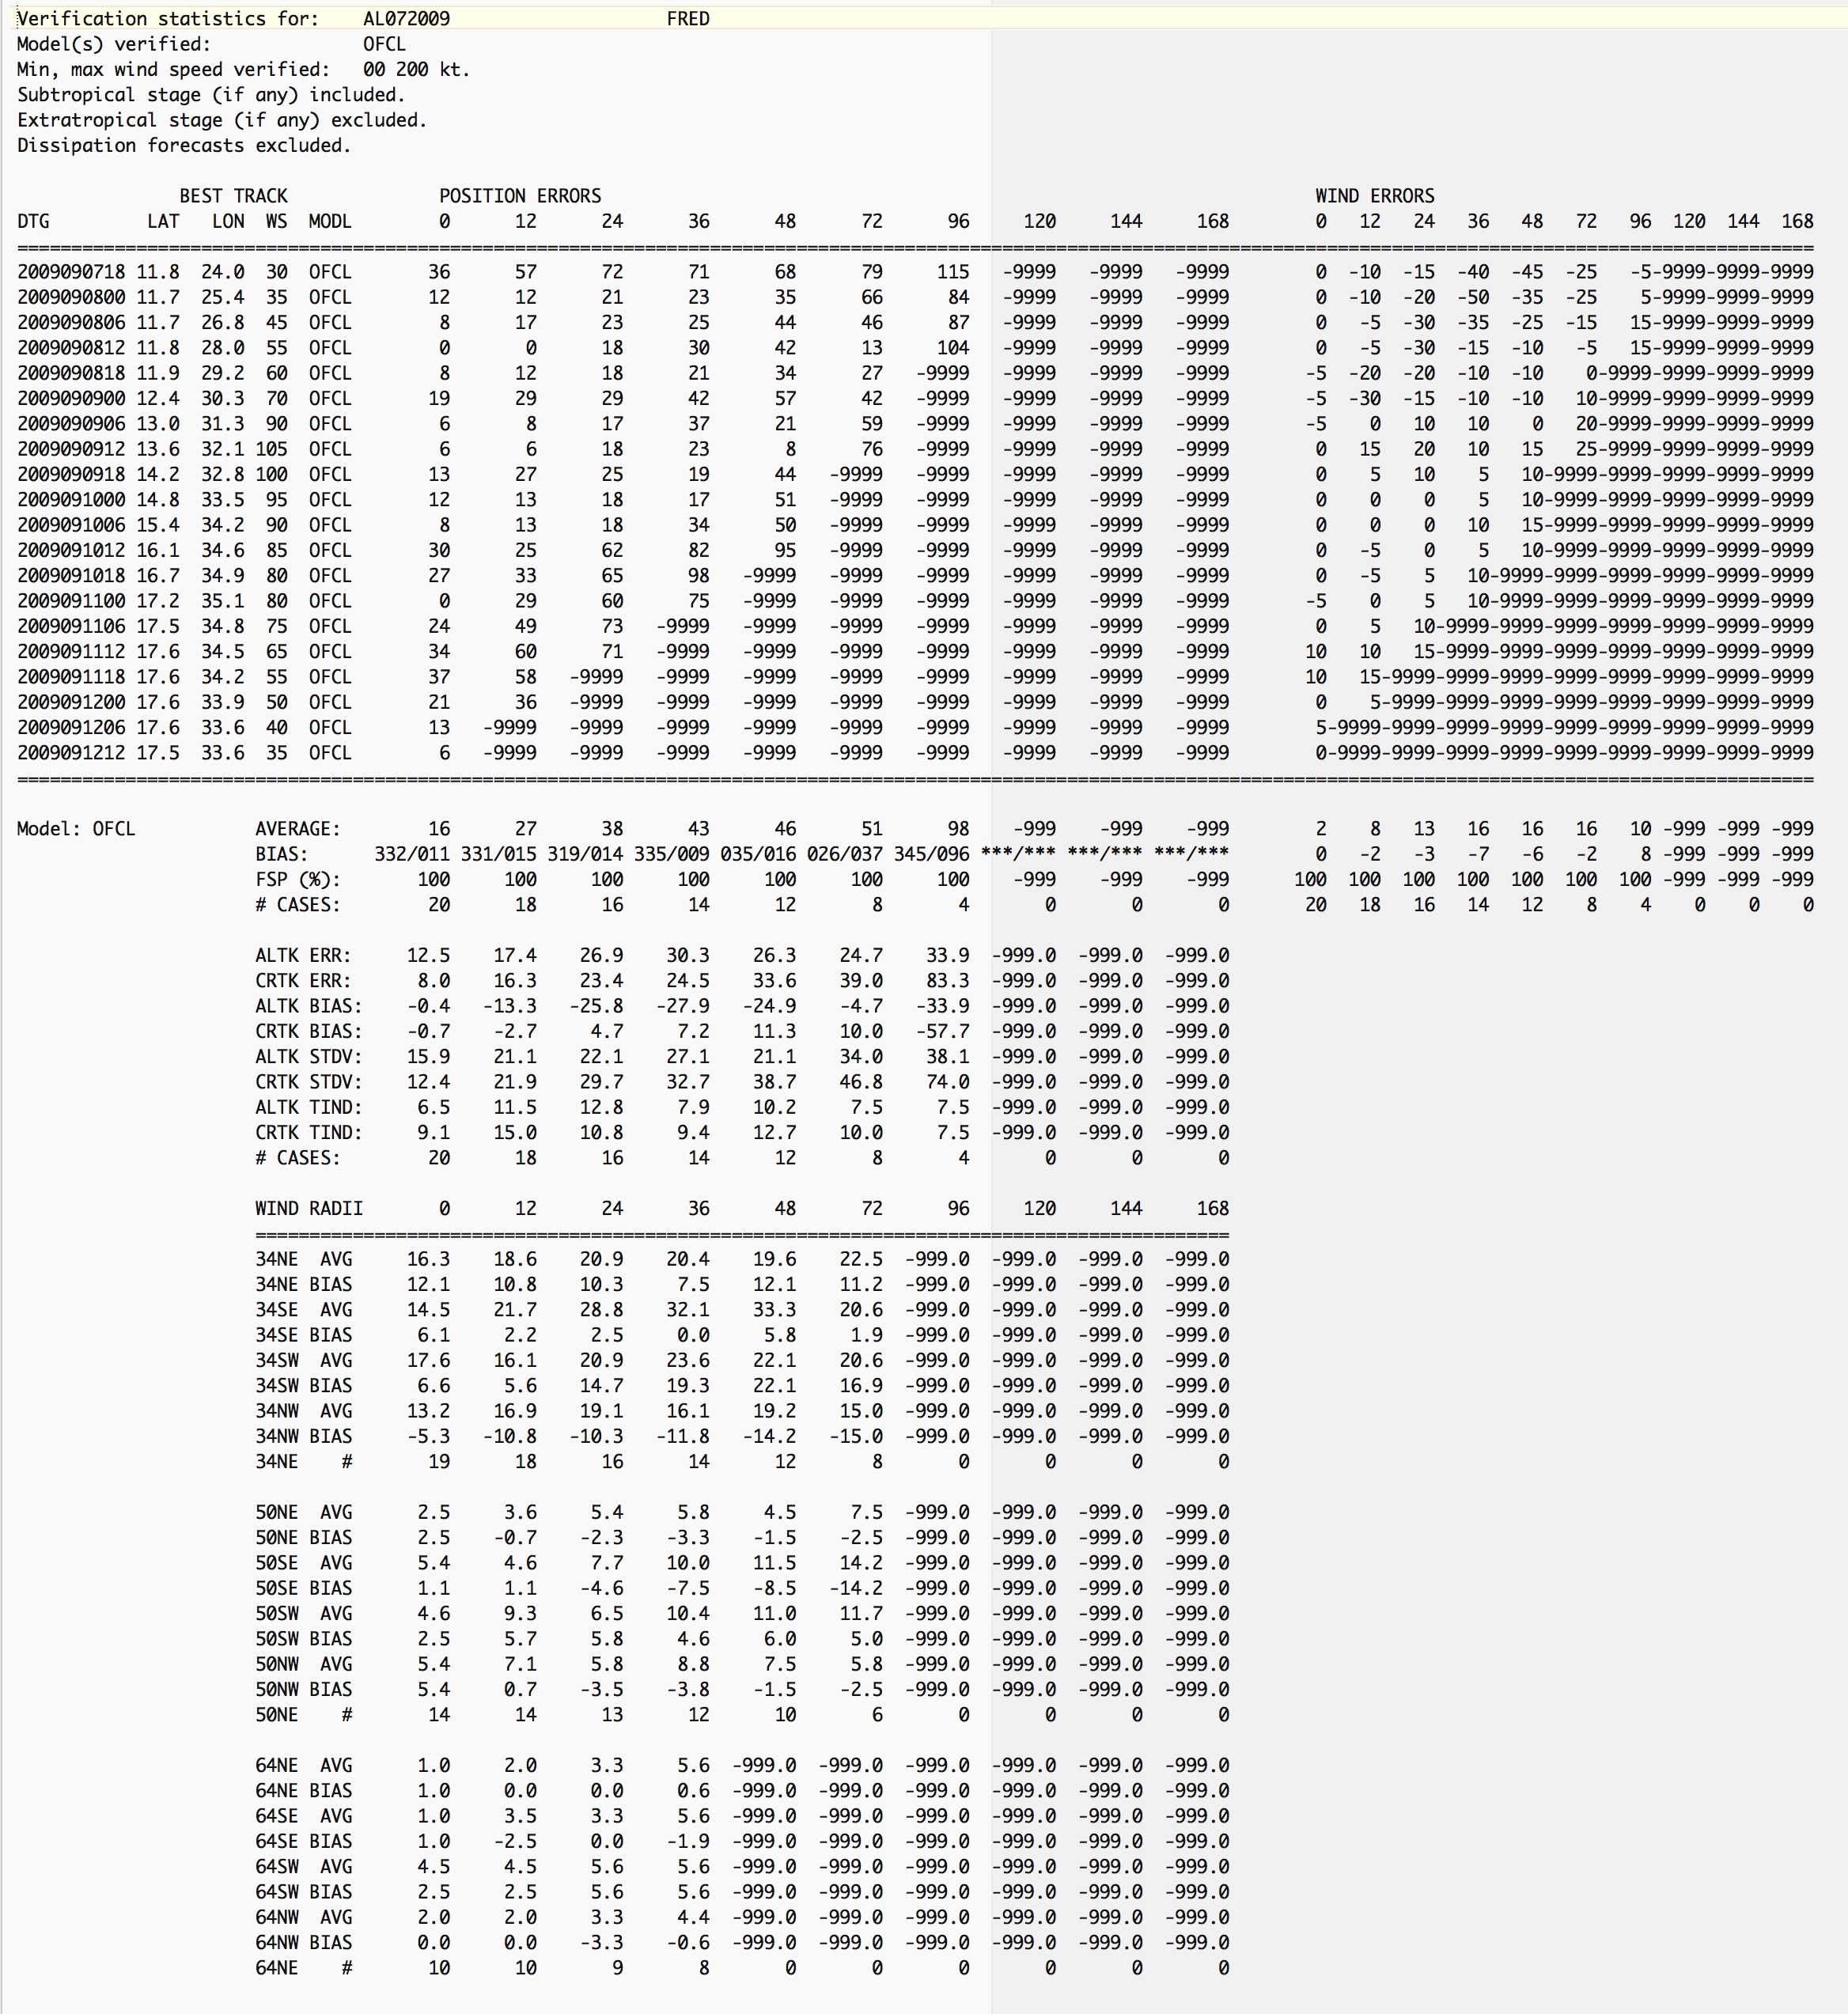

b. Condensed sample summary log: verifym_kgrf_[sampleID]_[model].txt
A single file providing just the basic summary results for the entire sample, where [sampleID] is the 8-character ID requested in verify_model.cmd (e.g., almy0813), and [model] is the first model requested. The parameters written to the file are determined by a setting in verify_model_options.dat. (The default content of this file is the track and intensity errors.)

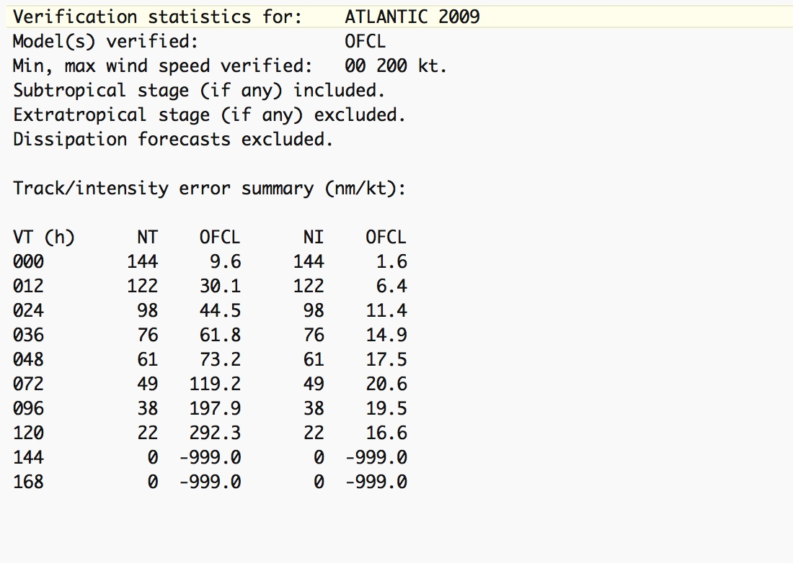

c. Expanded sample summary log: [sampleID]_[model].txt
This file contains a fuller set of output statistics than the condensed sample summary log, including along- and cross-track errors, radii errors, and biases. It also provides some comparative statistics for the various models in the sample (such as relative error and composite skill, the latter representing a combination of all forecast lead times).

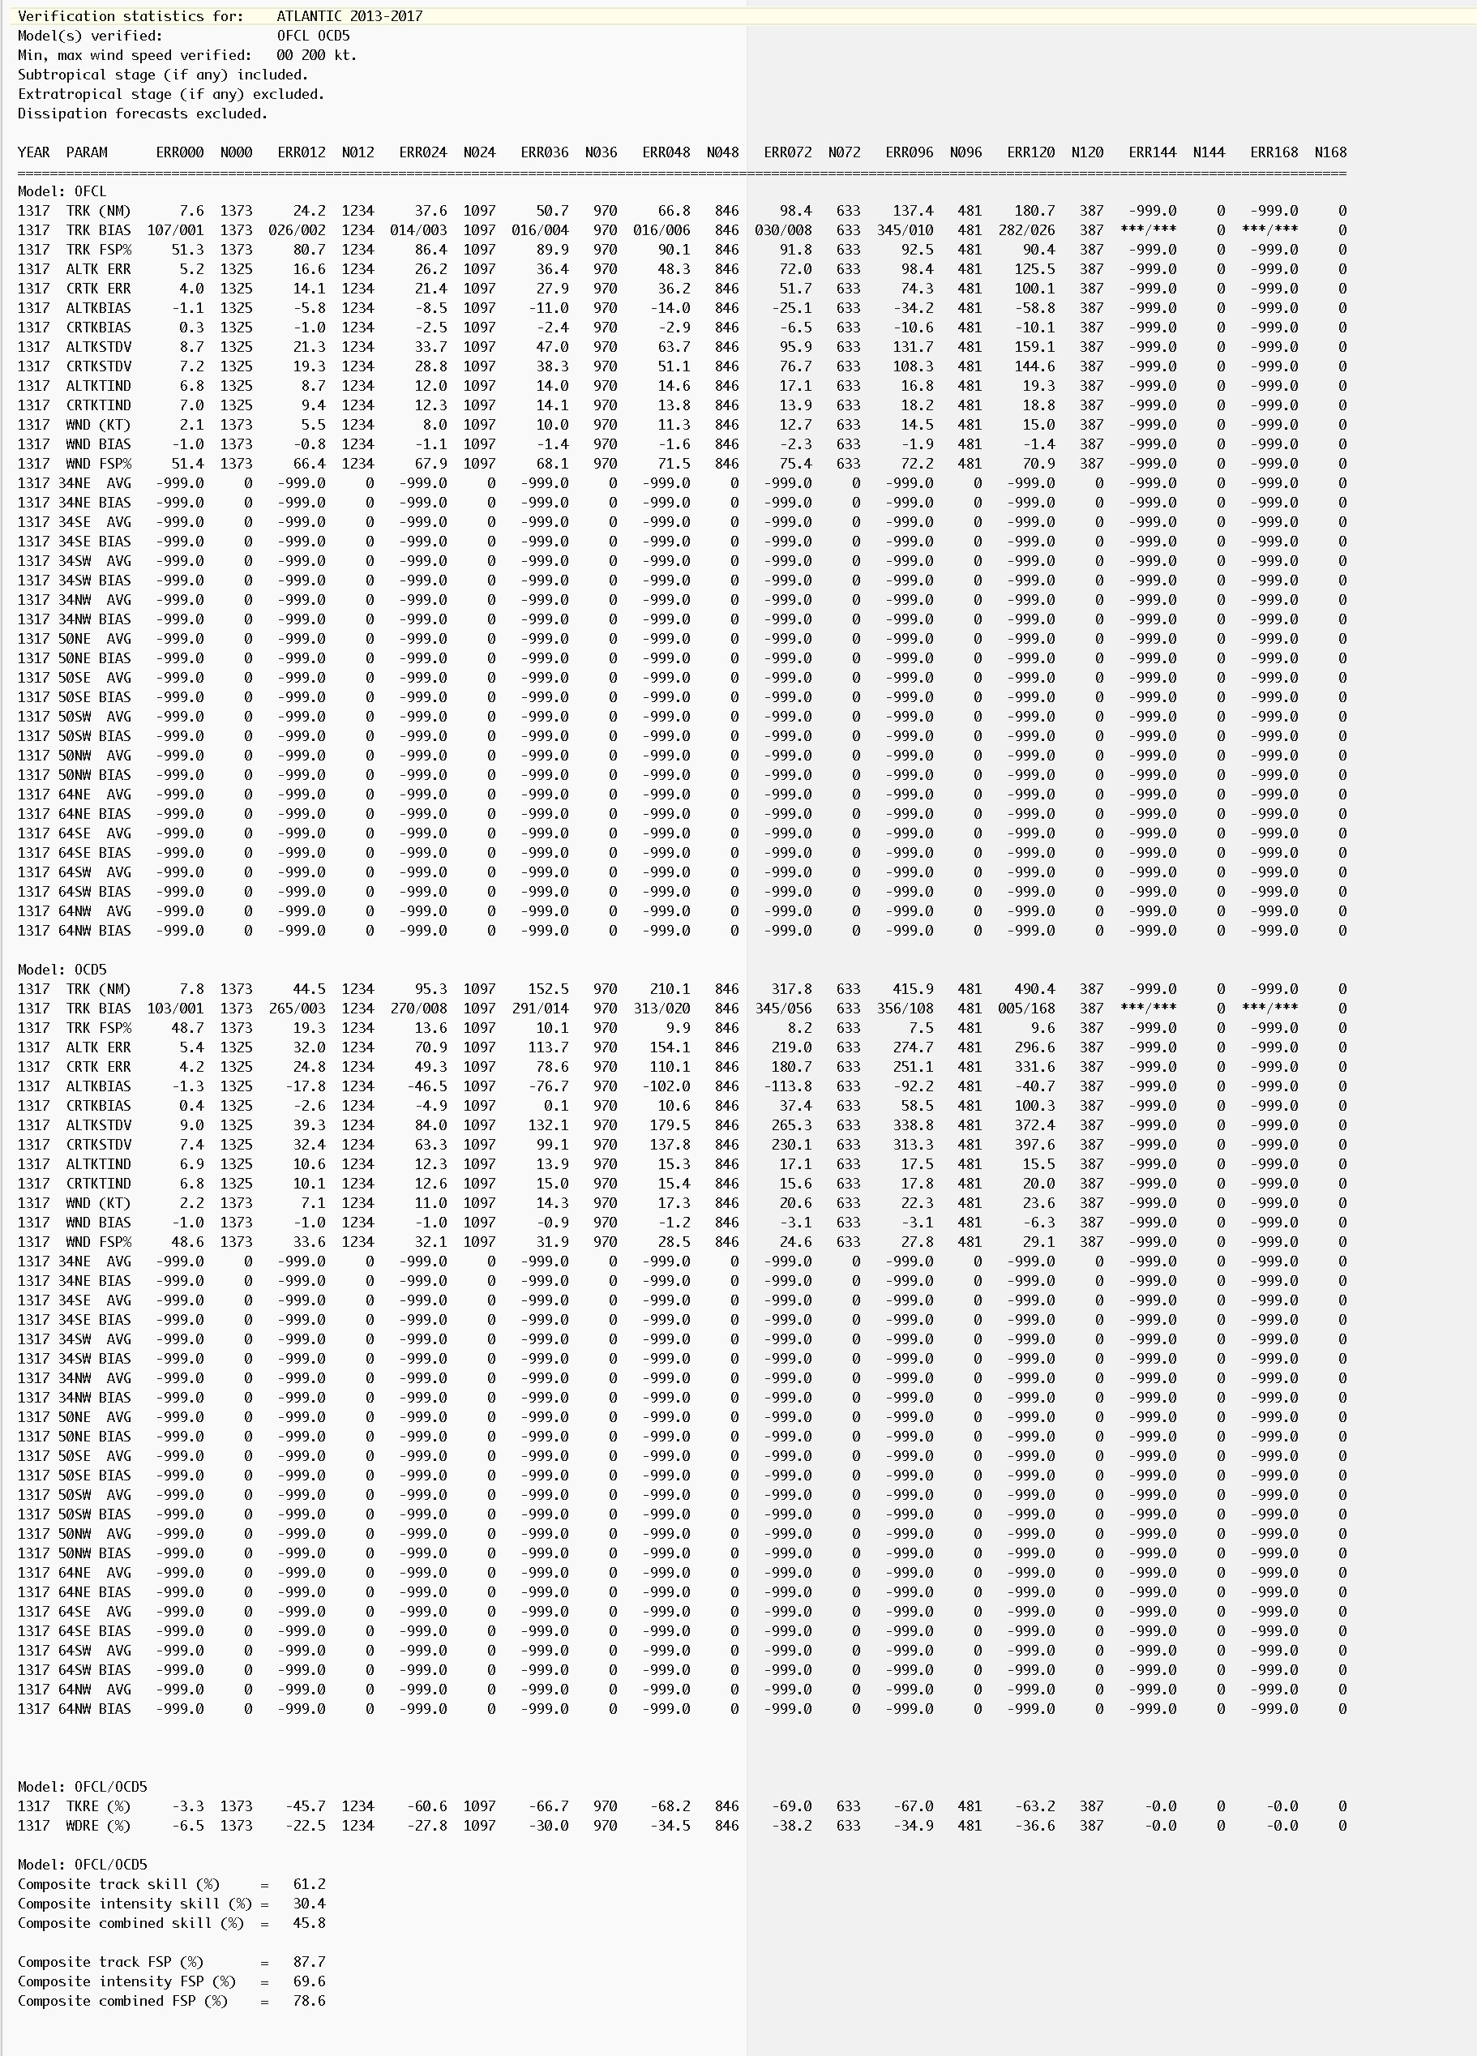
d. Spreadsheet log file: verifym_sprd_[sampleID]_[model].txt
A single file covering the entire sample, where [sampleID] is the 8-character ID requested in verify_model.cmd (e.g., almy0813), and [model] is the first model requested. This file contains a line by line result for each verification time in the entire sample for each model in the sample, where the output parameters are determined by a setting in verify_model_options.dat. A full description of the format of this file, which is suitable for importing into a spreadsheet for further analysis, can be found here. Note that these files have long lines (too long to display here) and lots of them.

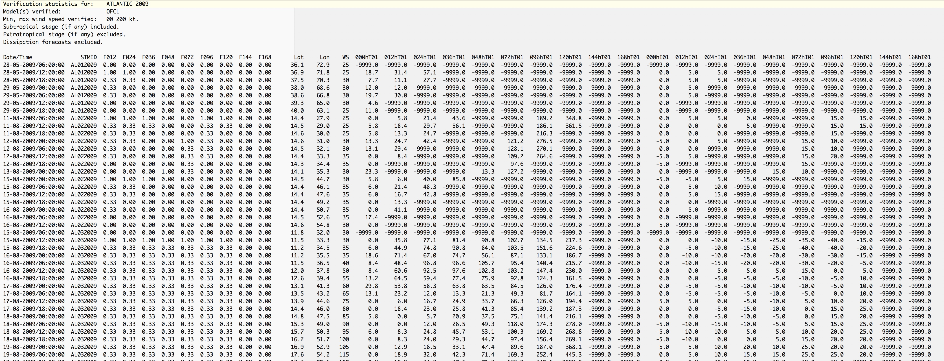

e. Collected track forecasts: verifym_allt_[sampleID].txt
This file supports generation of the multi-model verification track table that appears in the NHC Tropical Cyclone Reports, formatting the output with time increasing left to right and one row for each model.
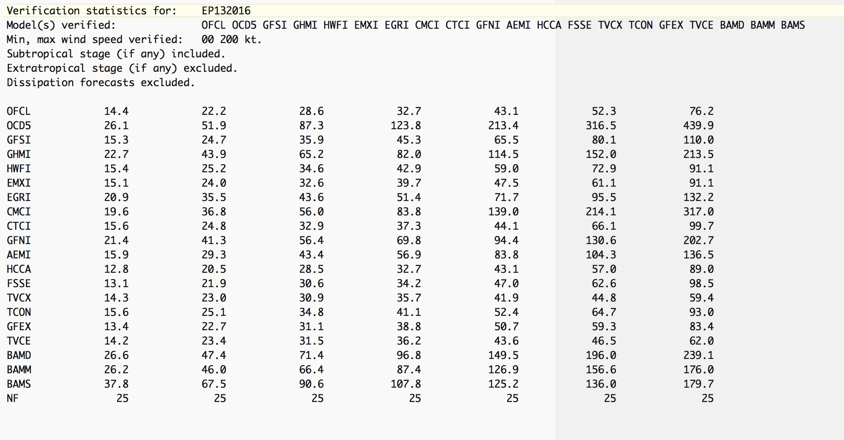
f. Collected intensity forecasts: verifym_alli_[sampleID].txt
This file supports generation of the multi-model verification intensity table that appears in the NHC Tropical Cyclone Reports, formatting the output with time increasing left to right and one row for each model.

- Special Notes and Gotchas
- Generating your own consensus: The program is able to generate a consensus on the fly, using the models in the a-decks. There are two types of consensus, fixed and variable. In a fixed consensus, all of the specified members must be present for the consensus to be calculated, while with a variable consensus the minimum number of required members is specified in verify_model_options.dat.
You can create and verify up to two fixed-member consensus aids. To create and verify a fixed-member consensus, edit one of the files verify_model_conx.txt or verify_model_cony.txt to specify the number of members and the specific desired membership of the consensus. When running verify_model.cmd, select your desired consensus by entering the model ID conx or cony, as appropriate. Note that the specified consensus membership will be used for both track and intensity.
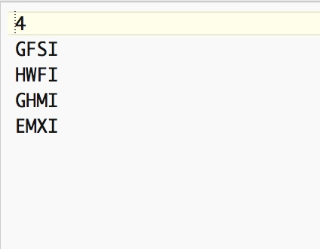
You can create and verify up to 10 variable consensus aids. To create and verify a variable-member consensus, edit one or more of the files verify_model_cona.txt through verify_model_conj.txt to specify the number of members and the specific desired membership of the consensus. You’ll need to specify the member models separately for track and intensity. When running verify_model.cmd, select your desired consensus by entering the model ID cona, conb, ..., conj, as appropriate.
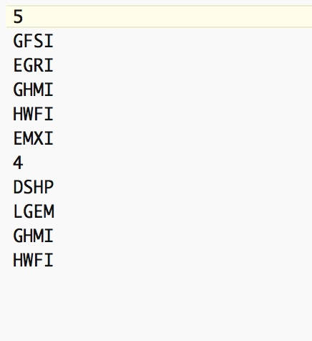
Consensus forecasts generated by the program are used in the verification but are not saved.
- Disregarding of special advisories: If both a regular and special official forecast are present for a date/time group, the regular forecast is the one verified (i.e., if “OFCL” is requested and OFCO is present, OFCO will be used instead of OFCL.) The idea here is to verify the original forecast, not the special issued later.
- Irrespective of what might be in the a-decks, the following invalid OFCL forecasts are tossed: no 0-h forecasts prior to 1970, no 12-h forecasts before 1967, no 36-h forecasts prior to 1988, no radii forecasts at 96 and 120 h, no 72-h radii prior to 2001, no 72-hr 50-kt radii prior to 1995, no 64-kt radii prior to 1995, and no 36-h 34- and 50-kt radii prior to 1988.
- Entering the model “TVCN” will accept occurrences of CONU (the model’s previous name). Entering “GFSO” will accept ATCF entries of AVNO. Entering “GFSI” will accept ATCF entries of AVNI. Entering EMH will be treated as a request for EMX, and all occurrences of EMH in the decks are treated as occurrences of EMX.
- If ACPALLST_IT is set to “Y” in verify_model_options.dat, then OFCP forecasts are accepted as OFCLs. This allows the inclusion of provisional forecasts along with forecasts for potential tropical cyclones.
- If a model appears more than once for a particular date/time group, the first occurrence is used. Supplemental a-decks are read before the regular a-decks.
- When verifying radii, un-forecast radii (e.g., if the forecast intensity is 60 kt there won’t be any forecast 64-kt radii) are set to missing, not to zero. Similarly, non-existent radii in the best-track are set to missing, not to zero.
- The models for which a 12-h interpolation can be substituted for a 6-h interpolation (e.g., UKM2 for UKMI) are listed in the file verify_model_intplist.txt. This file can be edited by the user when new interpolated model aids become available.
- Program will recognize that SHIP forecasts were included as LBAR in ATCF decks from 1996-98.
- When verifying a full year of storms, the program begins by looking for ATCF cyclone number 1 and looks for available files through cyclone number 39. If there are more than 39 storms in a given basin in a given year, probably everyone retired from NHC in exhaustion and no further verifications will be necessary.
- Skill baselines. OCD5 is a combination of CLIPER and decay-SHIFOR5, run on operational data. Calculation of OCD5 requires a CARQ line in the a-deck both for t=0 and t=–12. Because the t=–12 CARQ lines are not present in the a-decks before 1990, OCD5 cannot be computed for storms prior to 1990.
- BCD5 is a combination of CLIPER and decay-SHIFOR5, run on best-track data. Because it only requires data from the b-decks, it can be generated for any historical storm in the database.
- If the sample permits it, OCD5 is the preferable measure of skill, because BCD5 (being based on the best track) has the (unfair) advantage of information not known at the time the forecast was made.
- It is unclear if track errors are correctly calculated if the best track and the forecast are in different hemispheres. There’s a comment in the code that says this has been fixed, but not checked. Good luck.
- When calculating the frequency of superior performance, ties are counted as fractional wins.
- To specify all the forecasts from a particular storm in the forecast list file verify_model_fcstlist.txt, set the date/time group to 999999.
- The option to restrict the sample to those forecasts verifying within a box is used to compute errors in support of P-surge.

- Best Practices
- The following are standard NHC verification procedures:
A system must be a tropical or subtropical cyclone at both the forecast’s initial and verifying time to be included in the verification sample. All other stages of development (at either the initial or verifying times) are excluded.
The depression stage is included for current annual verifications and historical verifications from 1989 onward. (The a-decks do not contain forecasts for non-developing depressions prior to 1989.)
Special advisories are not included. When a special and regular advisory are both issued for the same synoptic time, the regular advisory forecast is verified.
If a 6-h interpolated model is not present at a given synoptic time (e.g., EMXI), then the 12-h interpolated model (e.g., EMX2) is used in its place.
- Verifications are only as reliable as the accuracy of the best tracks used for verification. While cyclone position uncertainty is a tiny fraction of the typical computed forecast error, even at t=12 h, intensity uncertainty can be a sizable fraction of the computed intensity errors and radii uncertainty can be as large or larger than the computed radii errors. Intensity analysis errors are believed to be about 10% of the cyclone intensity (e.g., +/–10 kt for a 100-kt hurricane), while radii analysis errors can easily be tens of nautical miles. For this reason, NHC has not included wind radii verifications in its annual verification reports.
- It is important to keep the contents of the data subdirectory current. It’s not unusual for historical decks to change, either from the workings of the Best Track Change Committee or to simply correct clerical errors. Be aware of updates to the historical archives. Similarly, the HSU periodically updates their copies of the watch/warning history files, so it’s good to check for updates from the HSU before doing any verifications based on watch/warning status.
- When evaluating forecaster performance, it is recommended to include the dissipation stage. This penalizes bad intensity forecasts when either the forecast or the best track dissipates the system.
- It is usually not helpful to compare forecast errors from different samples (i.e., non-homogeneous comparisons). When comparison of non-homogeneous samples is required (such as for a historical trend analysis), it is strongly recommended that the errors be normalized by a skill baseline, to help minimize whatever differences in difficulty might exist among the non-homogeneous samples.
- It is recommended to use verify_model to compute skill baselines on the fly, rather than rely on the contents of the a-decks. Although it is slightly slower to compute them than to read them, they’re sometimes missing from the official decks and you’ll lose forecasts that way.
- It is considered unfair to compare late and early (i.e., interpolated) models from the same synoptic time, since the late models have the advantage of being initialized from more recent data and a more current model run. For this reason, OFCL should always be evaluated against early models only.
- When comparing the performance of several intensity models, it is often illuminating to eliminate the after-landfall portion of the sample. Two models may have had different intensity forecasts because the two associated track forecasts had different encounters with land; including such differences in the sample usually isn’t helpful in isolating the models’ true relative intensity skills.

- Revision History

Version 4.11 (13 Sep 2021) contains the following change:
- Adds a new support file (verify_model_intplist.txt) containing a list of the 12-h interpolated “2” models which are used when the 6-h “I” interpolation is not available.

Version 4.10.2 (14 Jun 2021) contains the following change:
- Adds the option to determine the fractional case count (written to the spreadsheet file) based on the presence of intensity forecasts, rather than track forecasts. The fractional case counts can be used for statistical significance tests by Kaleidagraph or other post-processing applications.

Version 4.10.1 (3 Jun 2021) contains the following change:
- Adds an option to restrict the verification sample to only those cases where the forecasts differ. The check is done separately for track and intensity, and separately at each verification time; for example, if all of the models’ track forecasts at 72 h are identical, those 72-h track forecasts will be excluded from the sample.

Version 4.10.0 (08 May 2021) contains the following changes:
- Simplifies and expands the ability to run a verification over a combination of basins. This supersedes the kludgy method implemented in V4.6.0. Now, to do a combined verification for the eastern and central Pacific, you simply need to specify “EC” as the basin, and the program will automatically include all the appropriate EP and CP storms. Similarly, you can specify the basin as “AE” and you’ll get a combined Atlantic and eastern Pacific verification. Note that if you attempt to run a CP or EC verification but RLONMIN does not include at least a portion of the CP basin, the program will stop with an error message.
- Allows the various skill benchmark models (e.g., OCD5) to be run on CP storms. Note that the eastern Pacific coefficients are used and are of unknown applicability.
- Corrects a header formatting error in the individual storm log files introduced in V4.8.0.

Version 4.9.1 contains the following change:
- Update to treat EMH/EMHI/EMH2 as requests/occurrences of EMX/EMXI/EMX2.

Version 4.9.0 contains the following change:
- Modifies the way the sample is specified for multiple storms. The old paradigm of using “AL” to indicate a single year or range of years was about to fail; it would not, for example, be able to tell whether ALAL2021 meant the single year 2021 or the range 2020-2021. Now, characters 3-4 of the input ATCF ID should be “SY” to specify a four-digit single year, and “MY” if specifying two 2-digit beginning and ending years.

Version 4.8.1 contains the following change:
- Includes the 60-, 84-, and 108-hr OCD5 forecasts into the verification sample when OCD5 forecasts are generated by the program. Also includes these times when the option to save OCD5 forecast files is enabled.

Version 4.8.0 contains the following changes:
- Adds 60 h to the list of official NHC forecast times, meaning that 60-hr forecast verifications will now appear in program output when OFCL_SUP is set to Y.
- Corrects a bug introduced in V4.5.0 that mis-identified some verification times when watches and warnings were in effect. This bug would have affected verifications at 60 h and beyond when the selected forecast sample was (a) only those forecasts when watches/warnings were in effect at the verifying time, or (b) only those cases when watches/warnings were not in effect at the verifying time. All other program results are unaffected.

Version 4.7.0 contains the following change:
- Adds the ability to compute the HFIP RI metric, which defines the sample as those cases for which rapid intensification was either occurring or was forecast for a specified period ending at the verification time, including in any of the members of a user-specified consensus.

Version 4.6.3 contains the following change:
- Requires a comment line at the beginning of verify_model_fcstlist.txt. The comment (up to 60 characters) should describe what the list represents and will be echoed in the output log files.

Version 4.6.2 contains the following change:
- Implements OpenMP multi-threading for faster performance. The optimal number of threads is machine dependent and may require some testing to determine the optimal value for any particular installation. On the Mac, 2 seems to be the optimal value while a value of 4-6 seems best on Linux installations. Note that you can’t generate multiple versions of CLIPER (e.g., OCD5 and OCS5) with multi-threading on. If you need to generate multiple versions of CLIPER, set the number of threads to 1 in verify_model.cmd.

Version 4.6.1 contains the following change:
- Allows the verification sample to be restricted to times of rapid weakening.

Version 4.6.0 contains the following changes:
- Fixes a bug in the calculation of track errors if the forecast and verifying longitudes are on different sides of the Date Line. With this fix verification for the central Pacific basin is now fully supported.
- Allows a combined verification of EP and CP cyclones. This can be accomplished by copying the EP decks to the basin ID of “EC” (e.g., copy aep012015.dat to aec012015.dat). The CP decks must also be copied to a basin ID of EC, but in addition they must have distinct cyclone numbers not larger than 39 (e.g., copy acp012015.dat to aec312015.dat). Once the decks have been prepared, you can enter (for example) ecsy2015 when prompted for the storm ID. This would then verify all of 2015’s EP and CP storms as a single sample. (Note that this method has been superseded in V4.10.0)

Version 4.5.2 contains the following changes:
- Suppression of non-OFCL times when OFCL is part of the verification sample is now controlled in verify_model_options.dat.
- Changes the format of the storm output file to show average errors in tenths.

Version 4.5.0 contains the following changes:
- Adds verifications at the intermediate times 60, 84, 108, 132, and 156 h, whenever OFCL is not part of the requested homogeneous sample. Whenever OFCL is part of the sample, only valid (public plus experimental) OFCL verification times are output. In order to accomplish this, and to facilitate future updates to the verification times, substantial revisions were made to how the code manages verification times.

Version 4.2.0 contains the following changes:
- Adds a flag in verify_model_options.dat to discard ensemble member forecasts when the a-decks are loaded into memory. These individual ensemble members are hardly ever verified but take up a sizable fraction of the a-decks. Not reading them in greatly speeds up program execution.
- Increases the number of possible user-defined variable-member consensus aids from 2 to 10. These are now defined as cona, conb, …, conj.
- Allows the user to specify in verify_model_options.dat the wind speed and time interval thresholds for rapid intensification.
- Minor bug/formatting fixes.

Version 4.1.0 contains the following changes:
- Adds capability to have the forecast list apply to verification times as well as initial times.

Version 4.0.0 contains the following changes:
- Code revisions necessary to compile in gfortran on the Mac.

