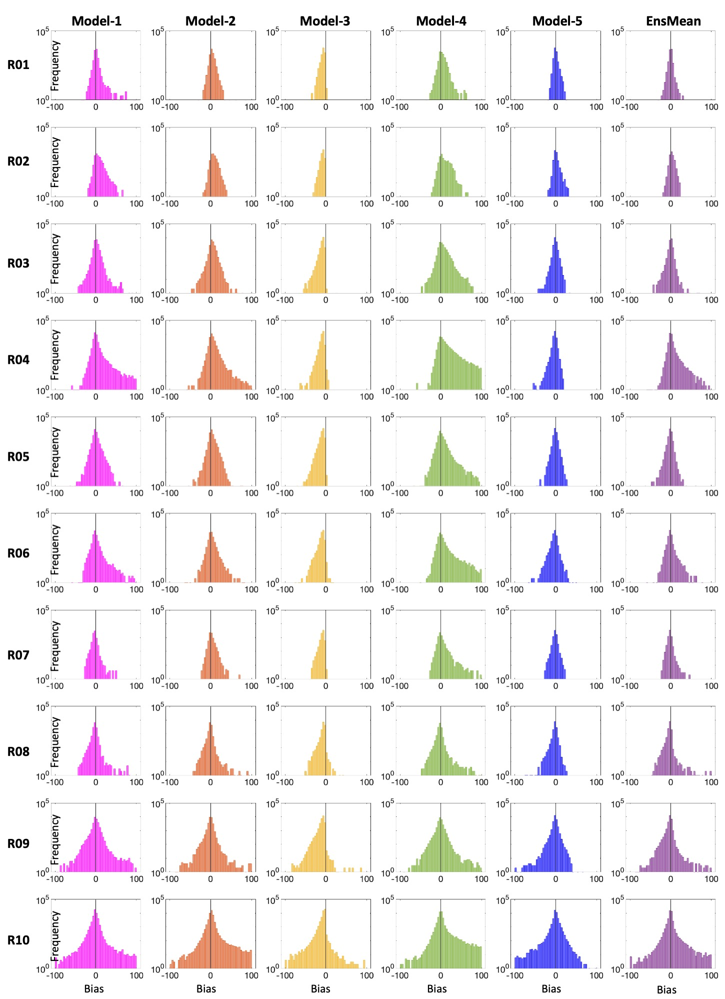
Fig. S1. Histograms of the model error for each individual model and the ensemble mean.

